AUTOMOBILE INDUSTRIES ANALYSIS



**1. Introduction**

This report analysis the performance of automobiles using Power BI. The goal is to gain insights into factors affecting performance analysis and identify areas for improvement.

**2. Methodology** 

The analysis will involve the following steps:

* **Data Acquisition:** Gather data on automobile performance metrics. This data can come from various sources from Base data in excel.
* **Data Cleaning & Transformation:** Clean the data to ensure accuracy and consistency. This may involve correcting errors, handling missing values, and formatting data for analysis.
* **Data Modelling:** Create a data model in Power BI to establish relationships between different data points.
* **Visualizations & Analysis:** Develop visualizations like charts, graphs, Pie charts and maps to explore performance trends, identify correlations, and uncover insights.

**3. Requirement Analysis**

The specific requirements for analysis will depend on the project goals. Here are some common areas of interest:

**Revenue Analysis**

* **Visualizations:**
  + **Line Chart:** Tracks revenue trends over a specified time period (e.g., months, quarters, years). This helps identify peak sales periods (e.g., holidays, seasonal trends).
  + **Pie Chart:** Illustrates the proportion of revenue contributed by each product category. This helps analyze which categories are most profitable.
* **Insights:**
  + Identify peak sales periods to optimize marketing campaigns and resource allocation.
  + Analyze product category contribution to revenue to prioritize resources and potentially develop new products.

**Units Sold Analysis**

* **Visualizations:**
  + **Bar Chart:** Shows the number of units sold for each product category. This reveals which categories drive sales volume.
  + **Trend Analysis:** Tracks units sold over time. This allows comparison of sales performance across different periods.
* **Insights:**
  + Identify product categories with the highest sales volume to focus marketing efforts.
  + Compare sales performance across time periods to assess growth or decline and adjust strategies accordingly.

**4. Other Parameters (Project Specific)**

Additional parameters can be included based on your project needs. These might encompass:

**Market Share Analysis**

* **Visualizations:**
  + **Stacked Bar Chart:** Represents the market share held by different brands within a specific market segment. This helps identify market leaders.
  + **Trend Analysis:** Tracks market share changes over time. This reveals how market dynamics are evolving.

Pen spark.

**Salary Analysis**

* **Visualizations:**
  + **Bar Chart:** Shows the total salary expenses incurred by each department. This helps identify departments with the highest payroll costs.
  + **Comparison Chart:** Compares average salaries across different job roles or departments. This allows for evaluation of salary distribution within the company.

**5. All Visualizations**

The specific visualizations will depend on the chosen parameters. Here are some potential charts you might include:

* **Scatter Plots:** Explore correlations between variables like horsepower and fuel efficiency.

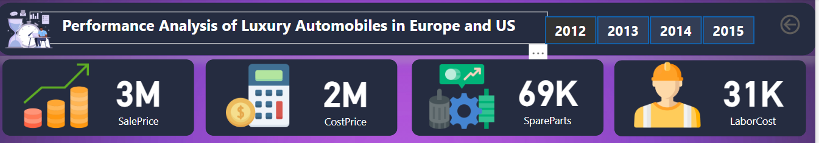

* **Bar Charts:** Compare performance metrics like acceleration across car models or segments.

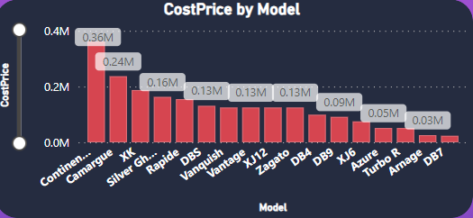

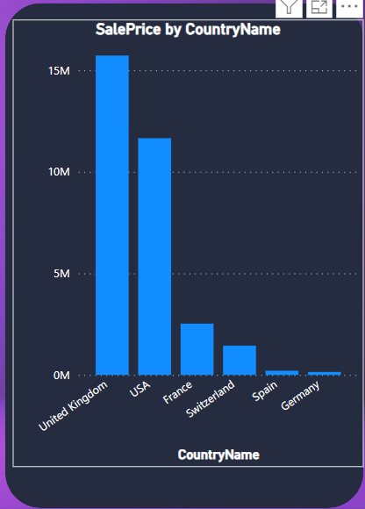

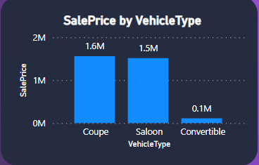

* **Line Charts:** Track trends in fuel economy over time or distance traveled.

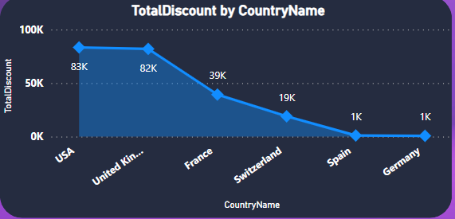

* **Maps:** Visualize fuel efficiency or performance variations based on geographical location.
* **Pie Charts:** Represent the distribution of cars by performance categories.

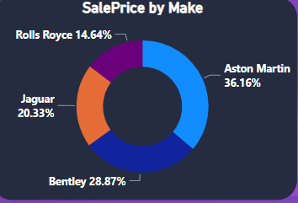

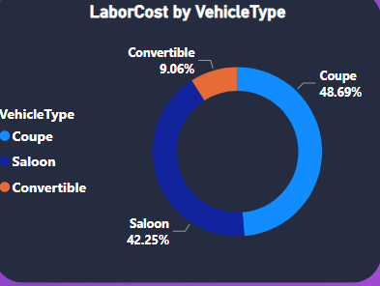

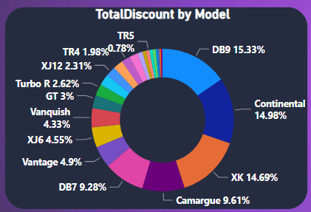

**6. Insights from Charts & Dashboards**

By analyzing the visualizations, you can gain valuable insights such as:

* Identifying car models with the best balance of power and fuel efficiency.
* Understanding how car price relates to performance metrics.
* Discovering the impact of environmental factors on performance.
* Uncovering trends in fuel efficiency over time.

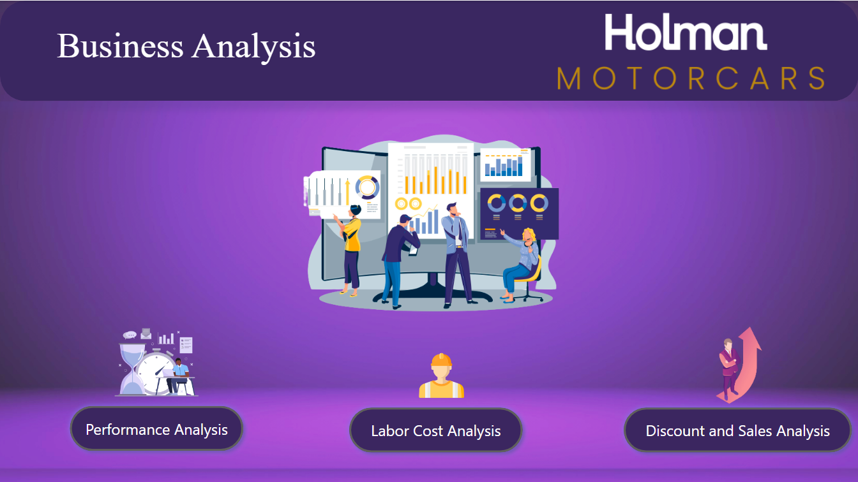

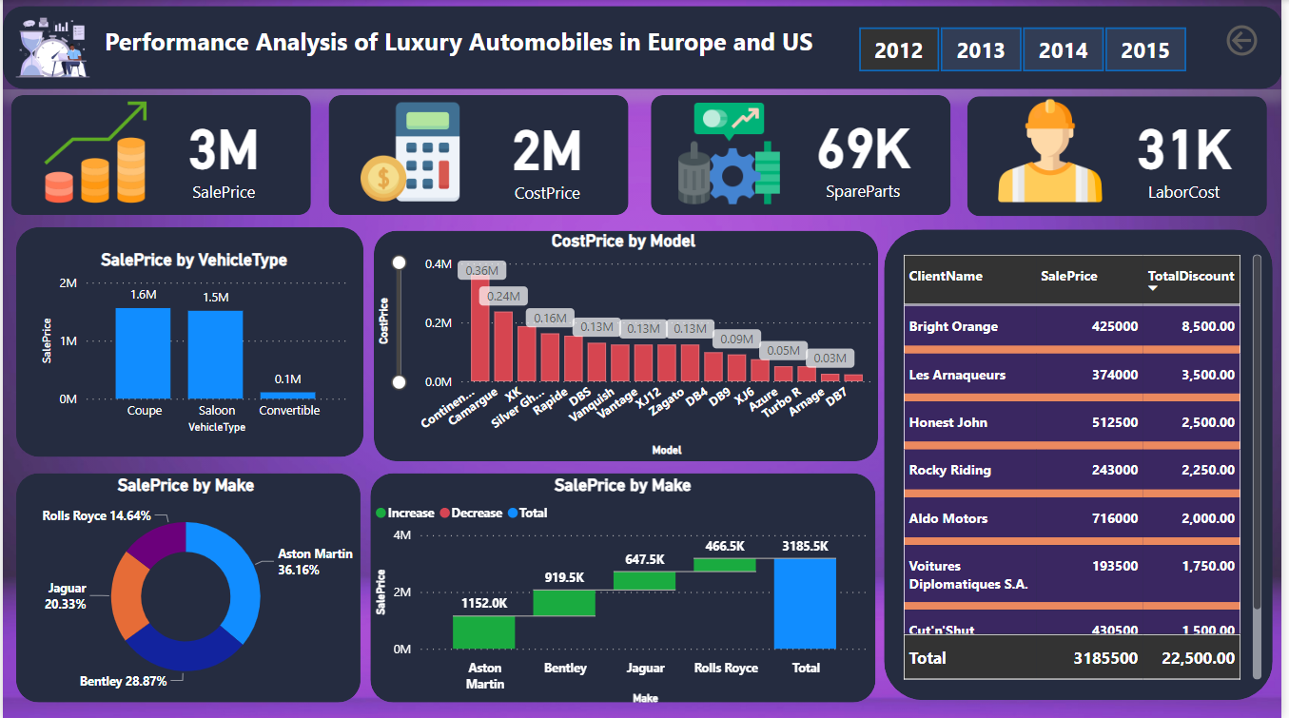

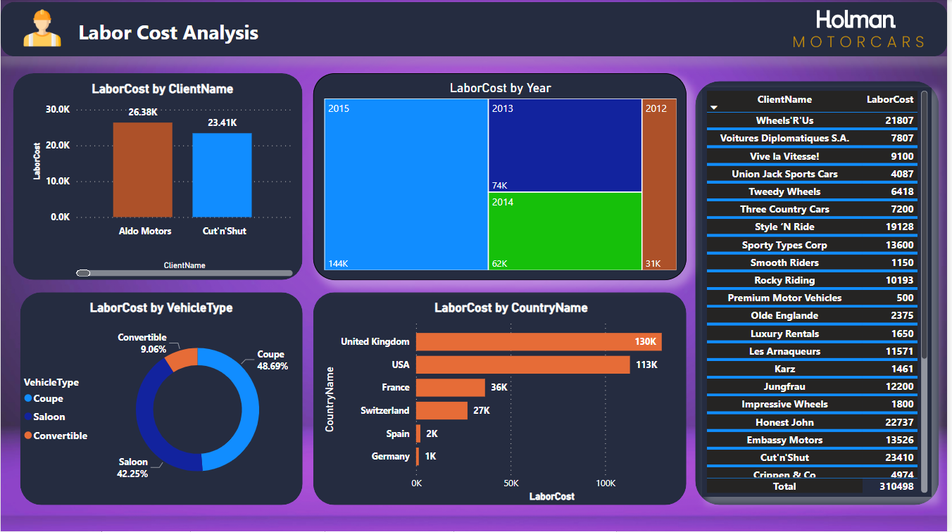

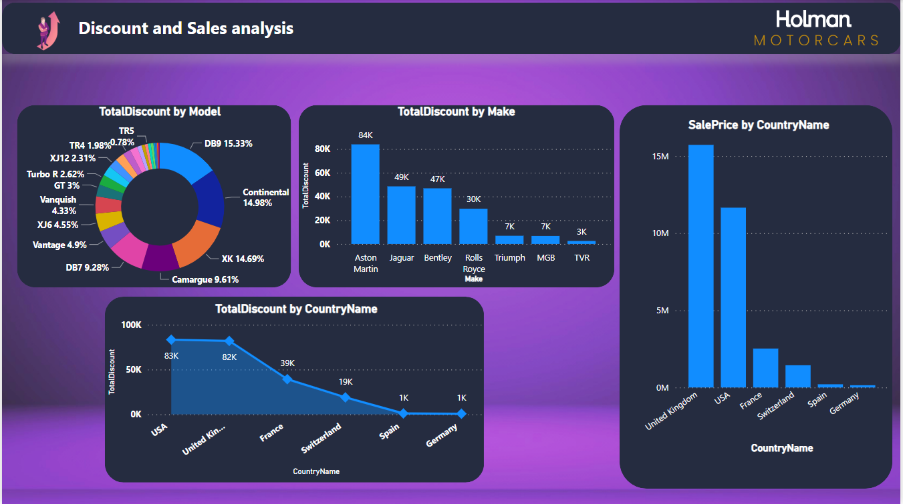

**7. Conclusion**

This PowerBI report provides comprehensive insights into automobile sales performance, labour costs, and the effectiveness of discount strategies. By analyzing these key metrics, stakeholders can make informed decisions to optimize sales operations and maximize profitability